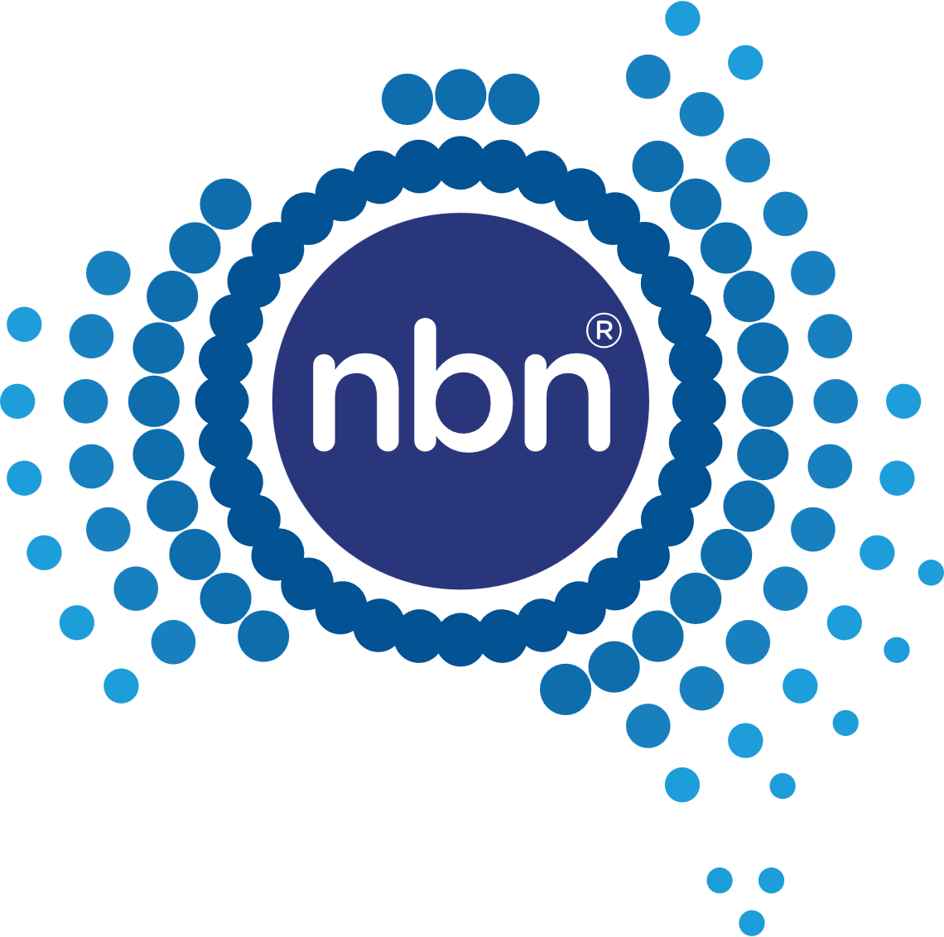
2023-2026

nbn
Accessibility and Inclusion Plan
Screen reader users will need to access this document in Read Mode.
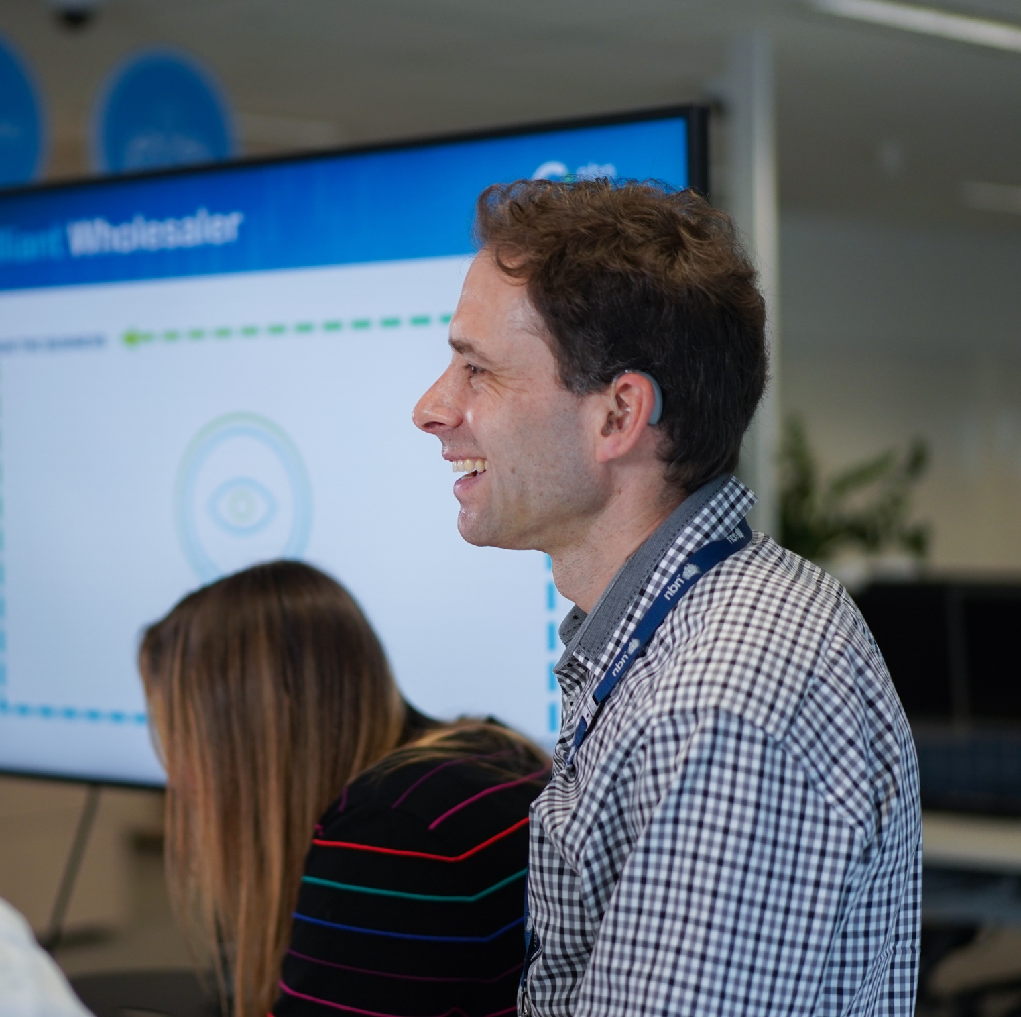

Contents
Message from Stephen Rue 3
Why this is important to nbn 4
Purpose 4
Sustainability Approach 4
Message from Corene Strauss 5
Supporting a national approach 6
Australia’s National Disability Strategy 6
Social Model of Disability 6
Intersectionality 6
What disability means 7
Accessibility and Inclusion Plan
2023 – 2026 8
Part A - Customers, Community and Partners 9
Part B - People, Culture and Capability 11
Part C - Governance and Reporting 16

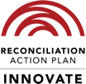
In the spirit of reconciliation NBN Co acknowledges the Traditional Custodians of country throughout Australia and their connections to land, sea and community. We pay our respect to their Elders past and present and extend that respect to all Aboriginal and Torres Strait Islander peoples today.

Message from Stephen Rue,

CEO nbn
The purpose of nbn is to lift the digital capability of Australia. This purpose guides our company and our people every day. It drives us on a mission to unlock social and economic benefits for households, businesses, and communities
from across our nation. A critical part of this is supporting vulnerable and marginalised people
by improving their access to reliable, secure,
and high-speed broadband.
Digital inclusivity is, therefore, essential to our purpose and a critical part of our role as Australia’s digital backbone.
Throughout the term of our first Accessibility
and Inclusion Plan (AIP), we have made steady progress towards this goal. Our first AIP has necessarily focused on foundational areas: establishing a vibrant Diversity, Equity and Inclusion community within nbn; improving accessibility in our own workplace through an emphasis on improved workplace adjustments and providing a mentally healthy workplace;
and, investing in programs with the Australian Network on Disability (AND), a national not-for-profit that helps organisations engage with people with disability.
Our updated Accessibility and Inclusion Plan, covering the years 2023 - 2026, pushes our ambitions for the inclusion of people living with disability further.
It sets out how we will support communities in a time of rapid technological change and increased digitisation, with a focus on accelerating access to healthcare, education, and other online government services. We are also working to deliver accessible and inclusive products and services for our customers, as well as people in the broader community. As always, we aim to provide an increasingly inclusive workplace for our employees.
Importantly, nbn’s AIP reflects the Australian National Disability Strategy, and incorporates recommendations from our inaugural Accessibility and Inclusion Index submission
with Australian Network on Disability.
Accessibility is critical to our social value approach and is an integral part of our sustainability framework. We know that digital technology is a great enabler for all members of the community and offers specific benefits for people with disability in particular. Connected devices allow people to live with greater dignity and independence, and for longer.
We continue to dedicate resources and capital into digital inclusion through our Low Income Digital Inclusion Forum, and to help remote and regional areas of Australia to stay connected, including First Nations and isolated communities.
All of our commitments under the updated Accessibility and Inclusion Plan are in line with nbn’s charter as a Government Business Enterprise. In particular, the Statement of Expectations issued to nbn by the Federal Government in December 2022 reinforces our commitment to promoting digital inclusion and equitable access to affordable, resilient, and reliable broadband services.
nbn is passionate to continue working with all levels of government, internet providers and advocacy groups to help create a more digitally equal society. When it comes to digital inclusion and accessibility, no-one should be left behind. This is our goal and what our updated Accessibility and Inclusion Plan aims to enable.
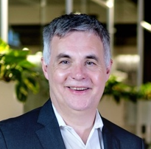

Stephen Rue
Chief Executive Officer

Why this is important to nbn

Purpose
nbn's purpose is lifting the digital capability of Australia. Accessibility and inclusion is core to achieving our purpose.
The Company recognises its role in digital inclusion, including providing accessible products and services for people and customers with disability and access needs.
People with disability experience challenges to workforce participation and internet connectivity. Improving lived experience, for employees and customers, starts from within. The company’s approach to accessibility and inclusion is underpinned by its culture and the capability of people who work at nbn.

Sustainability Approach
nbn’s Sustainability Approach recognises how both social and environmental themes are interdependent, function as a system, and are enabled and controlled by governance.
nbn’s Accessibility and Inclusion Plan 2023 – 2026 supports the Company’s Sustainability Approach and its social objective - Enhance and protect social value by lifting the digital capability of Australia and enabling equity across our value chain – by including goals and actions which address diversity, equity and inclusion in the Company and the communities it serves and help enable digital equity across Australia.
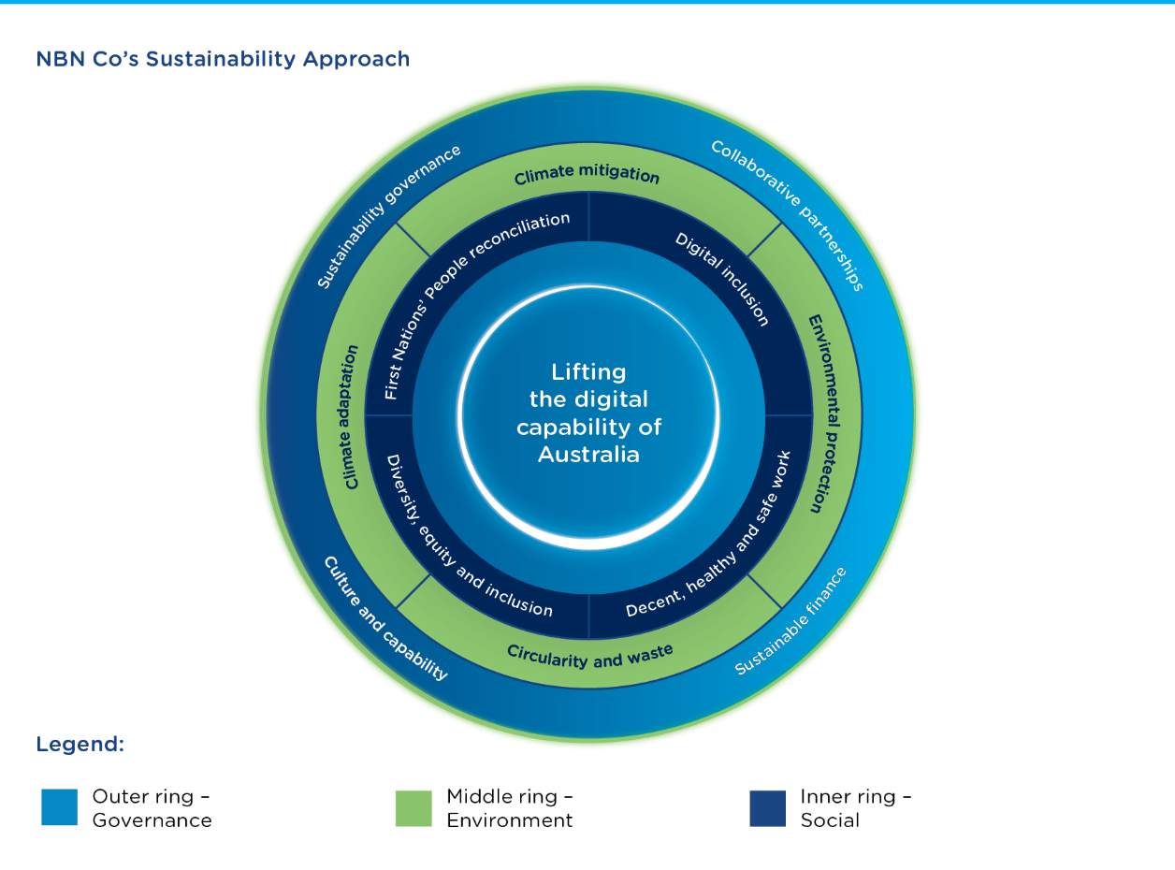

Source: Australian Institute of Health and Welfare Report, People with disability in Australia, AIWH Website. Australian Digital Inclusion Index, www.digitalinclusionindex.org.au This is the most current data available at the time of producing this plan.

Message from Corene Strauss,

CEO Australian Network on Disability
The Australian Network on Disability congratulates nbn for releasing an ambitious Accessibility and Inclusion Plan 2023 - 2026.
Like the Australian Network on Disability, nbn is playing a key role in unlocking social and economic benefits for businesses and communities across Australia. This plan enables nbn to ensure their culture, systems and practices are accessible and inclusive, welcoming people with disability in all aspects of its business.
As a partner on this journey, the Australian Network on Disability has seen nbn achieve many goals: including participation in our Access and Inclusion Index benchmarking tool; connecting with talented university students with disability through our Stepping Into Internship Program and job seekers with disability through our PACE Mentoring Program; and building workforce capability through the delivery of disability confidence training to over 200 staff.
Informed by the Access and Inclusion Index,
this plan set outs nbn’s actions for the next three years and demonstrates a commitment to being informed by people with disability at all stages of its implementation.
We wish nbn every success with the implementation of this ambitious Accessibility and Inclusion Plan.


Corene Strauss
CEO, The Australian Network on Disability
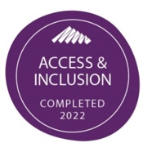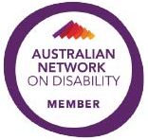

Supporting a national approach

Australia’s National Disability Strategy
nbn’s plan has been developed in line with Australia’s Disability Strategy 2021 – 2031, which sets out the nation’s disability policy framework
to improve the lives of people with disability in Australia over the next decade.
Australia’s National Disability Strategy 2021 – 2031 sets out Australia’s commitments under the United Nations Convention on the Rights of Persons with Disabilities (UN CRPD). It commits the nation to actions which “play an important role in protecting, promoting and realising the human rights of people with disability”.
Explicit in the national strategy is the social model of disability and intersectionality.
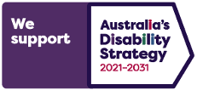

Social Model of Disability
nbn’s Accessibility and Inclusion Plan reflects the social model of disability, acknowledging the company’s responsibility to ensure that its workplace environment, activities, and the network it develops are created accessibly and inclusively – for employees, customers, communities, partners, and the
nation as a whole.
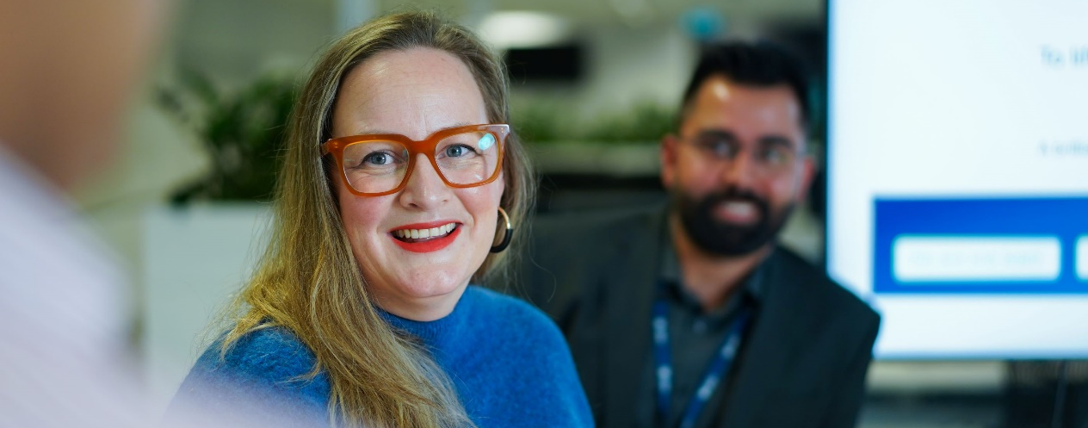

Source: Australian Institute of Health and Welfare Report, People with disability in Australia, AIHW Website. Australian Digital Inclusion Index, www.digitalinclusionindex.org.au This is the most current data available at the time of producing this plan.
“Australia’s Disability Strategy 2021–2031 calls
on all Australians to ensure people with disability
can participate as equal members of society.”

Intersectionality
Intersectionality is when people face more than one type of discrimination at a time. It recognises that people, and groups of people, can be affected by multiple forms of discrimination and disadvantage, overlapping and compounding effects.
The importance of intersectionality is illustrated through the increased prevalence of disability within Indigenous, LGBTIQA+, seniors, women and those living in regional and remote Australia. Our ability to deliver on our Reconciliation and Action Plan, diversity, equity and inclusion goals, and digital inclusion strategies are strengthened through awareness and application of an intersectional approach.

What disability means

Around 4.5 million people in Australia have some form of disability, this equates to approximately 17.7% of the population. This increases with age,  with one in nine (11.6%) of people aged 0-64 years and one in two (49.6%) people aged 65 years and over, having a disability.  When it comes to internet connectivity, the Australian Digital Inclusion Index identifies digital inequity across the Australian population, including people and households with a disability. People  with disability experience lower rates of internet connectivity. Disability is also highly prevalent in many groups that also experience high levels of digital exclusion. For example, older people living  in Australia experience disability at 50%,  First Nations people at 24% and those living in poverty at 36%.  When it comes to employment, around 12% of the working age population has a disability, with only 48% of working-age people with disability participating in the workforce. This number is persistently low and has remained steady for  over 30 years.  There is a 32% gap between the employment  rates of working-aged people in Australia who  do not have disability (80%) and those who do (48%). As reported in the Sydney Morning Herald  in 2023, the gap of 32% is much higher than countries such as Sweden – 9.5%, Finland – 12.4%, France – 9.9% and Italy – 13.3%.  As work, education and employment opportunities move online, we have seen how fast, reliable,  and secure internet connectivity facilitates better health, education, and employment outcomes. | Key Statistics  4.5 million  people in Australia have some form  of disability  32%  gap between the employment rates of working-aged Australians with and  without disability  49.6%  of people aged 65 and over who have  a disability  12%  of the working age population has  a disability

Sources: Australian Bureau of Statistics (2018), Disability, Ageing and Carers, Australia: Summary of Findings, ABS Website. Australian Institute of Health and Welfare Report, People with disability in Australia, AIWH Website. Australian Digital Inclusion Index, www.digitalinclusionindex.org.au This is the most current data available at the time of producing this plan. https://www.
smh.com.au/business/workplace/how-australia-can-get-more-people-with-disability-into-the-workplace-20230215-p5cklc.html

Accessibility and Inclusion Plan
2023 – 2026

This Accessibility and Inclusion Plan outlines
the next stage in nbn’s accessibility and
inclusion maturity.
nbn is committed to being an accessible and inclusive employer and a customer-led service delivery organisation that upholds respect for human rights.

The goals laid out in this plan aim to strengthen that commitment while also reflecting the Company’s purpose and values and focussing on the following three key areas:
- Part A – Customers, Community and Partners
- Part B – People, Culture and Capability
- Part C – Governance and Reporting

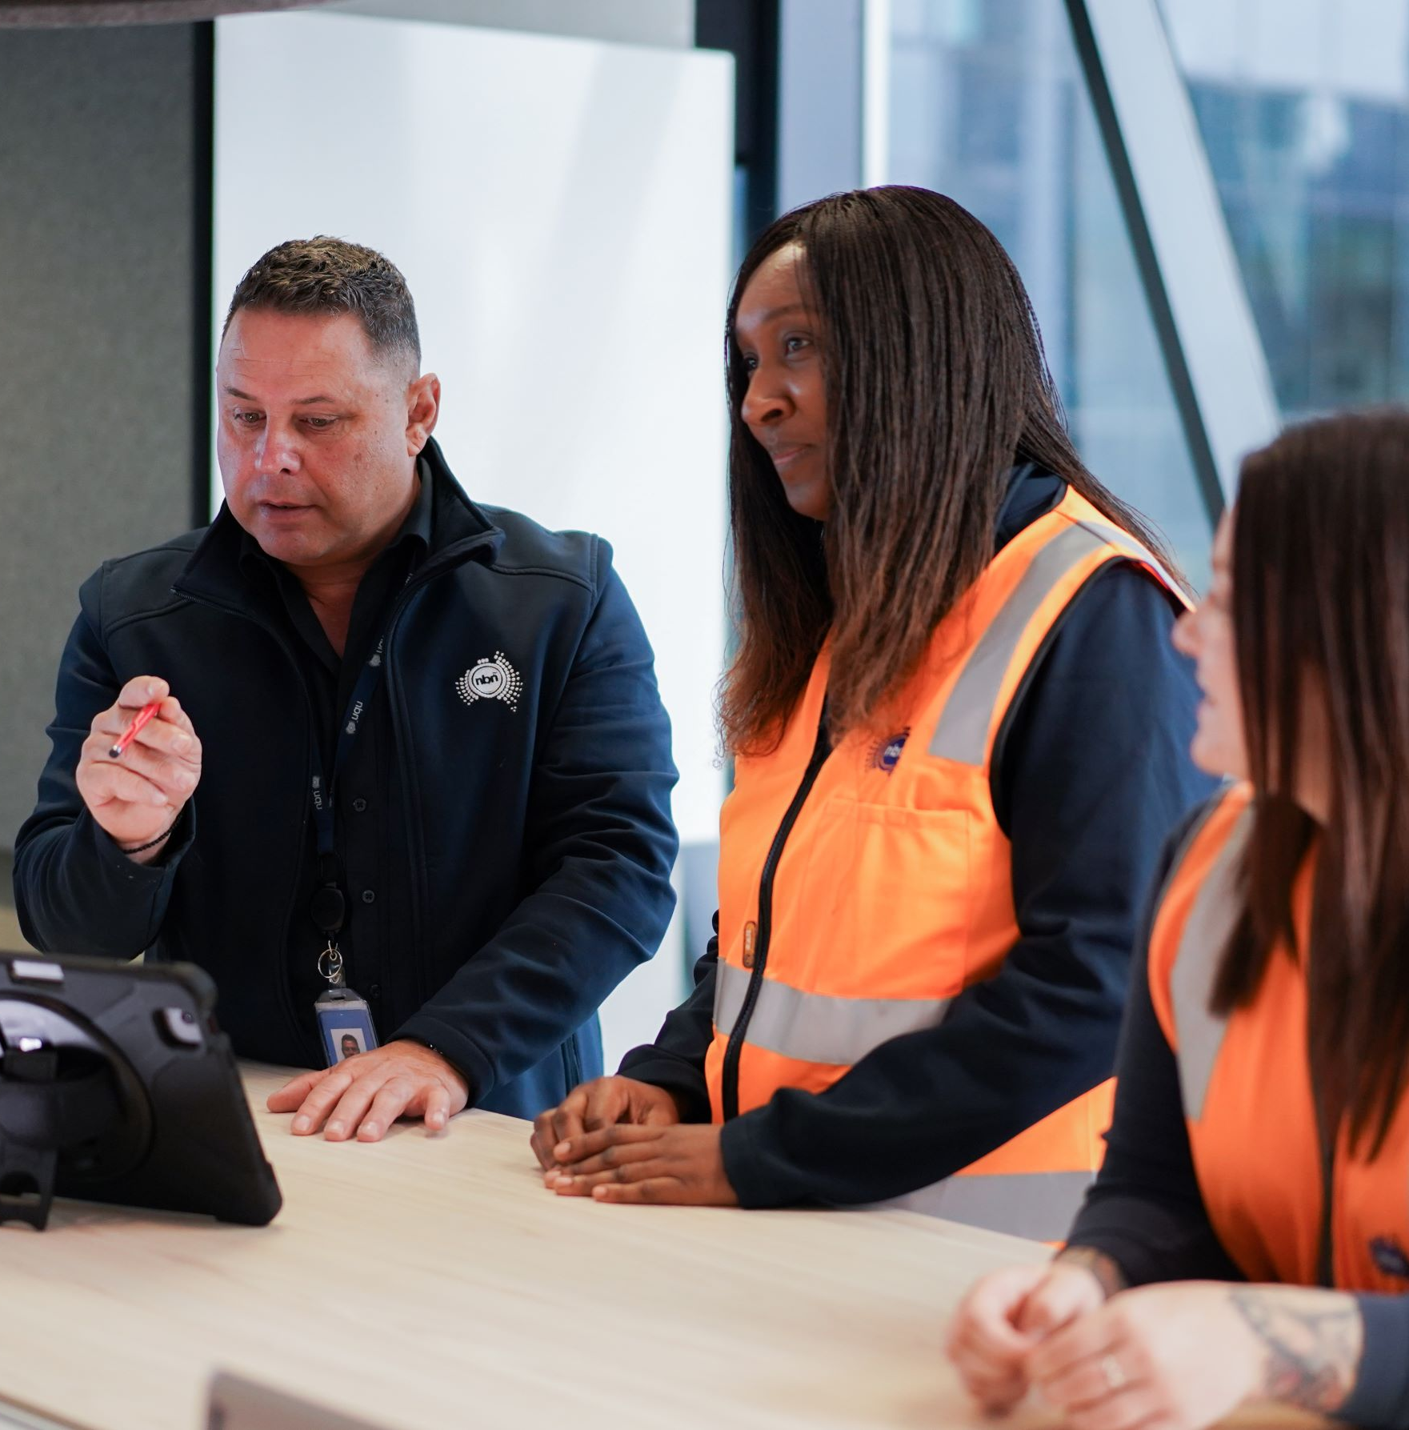


Part A
Customers, Community and Partners
The provision of accessible and inclusive
products and services to customers with disability or access needs is a key element of delivering
on our purpose of lifting the digital capability
of Australia.
Our goal is to improve connectivity
for customers with disabilities and address
digital inequality.
To achieve this, we must engage with customers and communities across Australia to understand
their needs, ensuring we also enable our industry partners to deliver our products and services with care and consideration.
Supporting our Sustainability Approach
– Digital Inclusion and Reconciliation
Action Plan.

Goal | Commitment
- Lived experience feedback is actively sought, valued and acted on.  This includes both customers with disabilities as well as those working with and supporting them. | - Establish formal listening posts and feedback loops to continuously improve customer experience, including from a range of audiences and users, on the accessibility of products, services, and communications.
 | - Establish guidelines for research, insights and feedback from customers with disability.
 | - Commit to including people with disability in research where they might be affected by decisions made using research.
 | - Conduct regular reviews of polices, processes and experience to ensure they remain up to date and fit for purpose. The review period may be frequency based, triggered by feedback, changes in laws or outcomes from relevant enquiries.
- Communications by nbn are accessible and inclusive, including nbn’s website (nbnco.com.au), marketing materials, social media and other content that is provided direct to the consumer, or to consumers via partners. | - Enhance the accessibility of nbn's brand.
 | - Develop and implement guidelines for accessible and inclusive communication. Do so with users who have accessibility or disability needs and create user personas if needed.
 | - Include accurate captions, audio description and or transcripts in advertising, marketing materials and external communications.
 | - Establish training plans to build the capability of employees so they can create accessible and inclusive communication and marketing materials for employees, customers, and industry.
 | - Provide ongoing professional development training for new and existing team members.

Goal | Commitment
- Products and services are accessible, inclusive and welcoming of customers with disability, and address nbn’s role in digital inclusion. | - Refresh nbn’s digital inclusion strategy, updating the focus on people with disability.
 | - Review existing network uplift programs with respect to the specific needs of accessibility and disability.
 | - Offer to establish a disability-specific working group as part of the Low-Income and Digital Inclusion Forum.
 | - Build awareness of needs and the capability to develop products and services for customers with disability.
 | - Review and adjust product development processes to include adequate considerations of people with disability.
 | - Complete an innovation program which includes people with disability in the criteria or target audience.




Part B
People, Culture and Capability
nbn is committed to accessible and dignified employment for people with disability. We aim to increase representation of people with disability within our workforce underpinned by recruitment and retention programs and a decent, healthy, and safe workplace.
nbn will support and enable its people to confidently and actively engage with people with a disability, in conjunction with fostering an inclusive and diverse workforce.
By growing disability confidence and workforce capability, we will enable more proactive considerations and deliberate decisions for customers, partners and future employees with
disabilities or access need.
Supporting our Sustainability Approach – Diversity, Equity and Inclusion and decent, healthy and safe work.
Goal | Commitment
- Our Diversity, Equity  and Inclusion pillars and initiatives continually raise awareness and improve disability confidence at nbn. | - Establish representation targets for employees with a disability and embed in Diversity, Equity and Inclusion, and People and Culture programs of work.
  - During the next stage of maturity:
  - Maintain and evolve an Accessibility Pillar in the overall Diversity, Equity, and Inclusion Community of Practice
(DEI CoP).
  - Actively seek out intersectional approaches to Diversity, Equity and Inclusion.
 | - DEI Team and Pillar members pilot and role model accessibility guidelines for internal communications including audio visual materials, events, and written content.
- Lived experience feedback is actively sought, valued and acted on.  This includes both employees with a disability and those working with and supporting them. | - Include disability in nbn’s People and Culture’s Listening Strategy. Include people with disability in research where they might be affected by decisions made using research. Establish formal listening posts and feedback loops to continuously improve employee experience.
 | - Establish a framework for user experience testing with employees, create user personas if needed.
 | - Establish an internal Disability Reference Group (DRG) to provide proactive and reactive feedback and advice on lived experience of people with a disability.
 | - Grow, evolve and maintain the internal DRG and usability testing use cases.
 | - Conduct regular reviews of policies, processes and experience to ensure they remain up to date and fit for purpose. The review period may be frequency based, triggered by feedback, changes in laws or outcomes from relevant enquiries.

Goal | Commitment
- Candidates, visitors,  and nbn employees experience seamless adjustments when requested and reasonable. | - Evolve and maintain the workplace adjustment process to ensure reasonable adjustments are available from recruitment through employment lifecycle.
 | - Leverage and modify workplace adjustment processes for visitors to nbn premises and events.
 | - Provide and support enablers for emergency planning, access, and egress, with a focus on visitors, customers, and others attending an nbn workplace, including asking all employees if they require a Personal Emergency Evacuation Plan (PEEP).
- People working for, and with nbn, experience a mentally healthy work environment. | - Review and maintain Safety and Wellbeing Policy commitments and underpinning management systems, in line with standards. Apply best practices principles that support accessibility.
 | - Embed focus on wellbeing tools, including Employee Assistance Program (EAP) and other resources, in employee onboarding materials.
 | - Maintain access to and promote mental health resources and confidential personal crisis management support for all employees.
- People working at, and visiting nbn premises and those attending an nbn event, experience dignified access. | - Involve employees in the establishment of design guidelines to ensure premise fit outs, upgrade and refurbishments meet Building Code of Australia, accessibility standards and provides dignified access. Seek to adhere to accessibility guidelines wherever reasonably practical.
  - Ensure nbn’s Property Policy and related documents explain
our commitments to accessibility and inclusion of people with disability.
 | - Include questions regarding the accessibility of premises in the post occupancy review process.
 | - Conduct a review of nbn buildings for dignified access, and where necessary develop action plans covering wayfinding, accessible toilets, hearing loops and accessible furniture.
  - Develop checklists to guide the hosting of internal and external events to cover:
  - Asking before events
  - Hybrid event protocols
  - Awareness of disability and accessibility-specific
evacuation procedures

Goal | Commitment
- A welcoming and inclusive recruitment process, with specific considerations given to people with disability and access needs. | - Aspire to be a certified Disability Confident Recruiter by 2026.
 | - Review talent acquisition / recruitment processes to identify and remove unintended barriers for recruitment streams, including graduate intakes.
 | - Maintain a talent acquisition / recruitment process, which are easy and usable for candidates, recruiters, internal recruitment teams and hiring managers.
 | - Update feedback survey to ask candidates about their talent acquisition / recruitment experience, and the accessibility of the recruitment process.
 | - Establish feedback processes for hiring managers, interviewers and recruiters to understand and improve the process of interviewing and hiring candidates with disability or access needs.
 | - Ensure recruitment agencies and outsourced talent acquisition teams are aware of nbn’s commitment, expectations, and process, to support accessible and inclusive recruitment.
 | - Expand agency meetings to include nbn’s expectations and suppliers market knowledge.
 | - Ensure decisions on nbn's recruitment agencies include an assessment of their accessibility and inclusion policies, practices, and credentials.
 | - Establish employment programs, schemes, and partnership opportunities to attract candidates with disabilities.
 | - Explore the use of disability-specific recruitment agencies.
 | - Ensure nbn's people strategies and core programs are reviewed and revised to improve disability confidence and employee experience, and support disability representation goals.
 | - Identify learning solutions for the talent acquisition team on barrier-free and inclusive recruitment.
 | - Provide regular training for people involved in recruitment, aligning to Disability Confident Recruiter Accreditation criteria.

Goal | Commitment
- Learning and development is accessible and inclusive, designed with disability needs in mind, including disability leadership. | - Include the unique needs of people with disability in career development and progression frameworks.
 | - Conduct an audit of enterprise mandatory and non-mandatory learning for accessibility.
 | - Develop and refine learning guidelines to include types of disabilities and create user personas if needed.
 | - Develop and implement frameworks to ensure all new learning content is designed against accessibility principles, including Website Content Accessibility Guidelines WCAG 2.1 AA (digital) and Universal Design principles (other).
 | - Develop learning solutions to build disability confidence and awareness for the workforce, in line with a continuous learning approach (general awareness and people-leader specific).
 | - Where necessary, develop role-specific capability building learning solutions to enable people to adequately consider disability and accessibility in their roles.
 | - Improve disability confidence and awareness of nbn’s Executive Committee through regular learning events.
 | - Make available information on how people can be supported to request a workplace adjustment, and include as part the induction process for new starters, and in training for those in existing learning solutions roles.
- Make digital experiences accessible and aligned to WCAG 2.1 AA standards, where practicable, for:  nbn employees  Industry platforms  Customer / consumer facing website  Other external facing, digital content | - Meet Website Content Accessibility Guidelines 2.1 AA standards for the nbn website.
 | - Review and update development guidelines, based on evolving practices and user feedback.
 | - Audit of frequently used intranet pages, informing an uplift program with clear timeframes.
 | - Establish user feedback mechanisms, including from those with a disability, for building, funding or approving internal Information and Communications Technology (ICT) platforms.
 | - Plan for accessibility requirements in software and hardware purchases and upgrades. Do so through feedback mechanisms which identify and scope access requirements for users with a disability, as well as customers, employees and industry.

Goal | Commitment
- Establish and embed accessibility guidelines in procurement decisions, with a focus on Information Communication Technology (ICT) products and services. | - Develop guidelines for how to include accessibility requirements in procurement processes. This includes both Request for Information (RFI) and Request for Proposal (RFP) processes.
 | - Where needed, establish expert support to evaluate supplier submissions and evolve nbn’s accessibility procurement practices.
 | - Ensure nbn’s Procurement Policy or related documentation explains our commitment to procuring products and services that are accessible for people with disability.
 | - Review and update Supplier Code of Conduct to state nbn’s commitment to accessibility and inclusion of people with a disability.
 | - Through the Supplier Code of Conduct, ensure suppliers are aware of nbn's commitment to accessibility.
 | - Enable and encourage suppliers to provide recommendations or suggest innovations to enhance accessibility.
 | - Actively consider aspects of Accessible Procurement Standards compliance by 2026. At time of publishing AS EN 301 549:2020.


Part C
Governance and Reporting

Governing nbn’s
Accessibility and Inclusion Plan
nbn’s Sustainability Sub-Committee of the Executive Committee (ExCo) meets regularly and oversees the implementation of the Sustainability Program of Work. This includes nbn’s Accessibility and Inclusion Plan and associated internal enterprise uplift programs.
To further support executive governance over the term of the Accessibility and Inclusion Plan, we commit to also undertaking:
- Regular reporting to the Executive Committee on implementation progress and successes of
the Plan
- Individual meetings with relevant ExCo members, commensurate with their
Business Unit accountabilities in the Plan
- Reporting progress as part of nbn's
Annual Report.

Accessibility and Inclusion Index
In 2022, nbn participated in the Accessibility and Inclusion Index with Australian Network on Disability. It has informed this Accessibility and Inclusion Plan and assisted in prioritising the delivery of the plan. nbn commits to submit to the Accessibility and Inclusion Index annually for the life of this Accessibility and Inclusion Plan.


For public inquiries about nbn's Accessibility and Inclusion Plan or for more information on nbn's Accessibility programs and initiatives visit our website or follow our social media pages.
Alternative Formats
This plan is available in alternative formats on our website
https://www.nbnco.com.au/corporate-information/careers/diversity-and-inclusion


Follow us

Twitter – @NBN_Australia

LinkedIn – @nbn Australia
Facebook – @nbnAustralia


Website – https://www.nbnco.com.au
YouTube – @nbn_australia


Contact us

Call us from within Australia on 1800 687 626
Email us – DiversityAndInclusion@nbnco.com.au

National Relay Service
If you need help to speak or listen, contact nbn through the National Relay Service.
Call the National Relay Service Help Desk 1800 555 660
Go to the National Relay Service Website communications.gov.au/accesshub/nrs

For Deaf, hearing or speech impairment services please contact: TTY phone 1800 555 677
and enter 1800 687 626. For Speak and Listen support services please phone 1800 555 727
and enter 1800 687 626 or go to nbn.com.au/SupportServices
If you need an interpreter, please call the Translating and Interpreting Service (TIS National)
on 131 450 and ask them to call the nbn Contact Centre



© 2023 NBN Co Limited | ABN 86 136 533 741
‘nbn’, ‘Sky Muster’, ‘business nbn’ and nbn logos are trade marks of NBN Co Limited.
nbnco.com.au

